Exercise 3: Stored Procedures
Aim
To implement PL/SQL stored procedures for processing monthly interest, updating employee bonuses, and transferring funds between bank accounts.
SAMPLE DATA:
Step 1: Create the Accounts Table
CREATE TABLE Accounts (
AccountID NUMBER PRIMARY KEY,
CustomerName VARCHAR2(50),
AccountType VARCHAR2(20),
Balance NUMBER(10,2)
);
Step 2: Insert Sample Data
INSERT INTO Accounts VALUES (101, 'Rahul', 'Savings', 50000);
INSERT INTO Accounts VALUES (102, 'Priya', 'Savings', 30000);
INSERT INTO Accounts VALUES (103, 'Amit', 'Current', 45000);
INSERT INTO Accounts VALUES (104, 'Sneha', 'Savings', 60000);
COMMIT;

Scenario 1: Process Monthly Interest
Objective
Write a stored procedure ProcessMonthlyInterest that calculates and updates the balance of all savings accounts by applying an interest rate of 1% to the current balance.
Step 3: Create the Stored Procedure
CREATE OR REPLACE PROCEDURE ProcessMonthlyInterest
IS
BEGIN
UPDATE Accounts
SET Balance = Balance + (Balance * 0.01)
WHERE AccountType = 'Savings';
COMMIT;
END;
/
Step 4: Execute the Procedure
BEGIN
ProcessMonthlyInterest;
END;
/
Step 5: Result
SELECT * FROM Accounts;
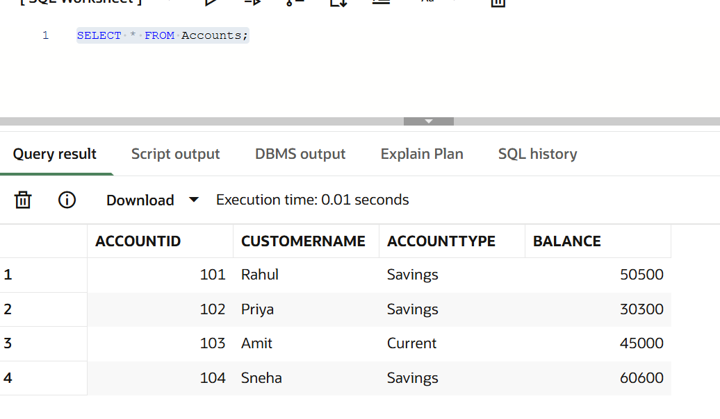

Scenario 2: Update Employee Bonus
Objective
Write a stored procedure UpdateEmployeeBonus that updates employee salaries by adding a bonus percentage to employees belonging to a specified department.
Step 1: Create the Employees Table
CREATE TABLE Employees (
EmployeeID NUMBER PRIMARY KEY,
EmployeeName VARCHAR2(50),
Department VARCHAR2(30),
Salary NUMBER(10,2)
);

Step 2: Insert Sample Data
INSERT INTO Employees VALUES (1, 'John', 'IT', 50000);
INSERT INTO Employees VALUES (2, 'Sara', 'HR', 45000);
INSERT INTO Employees VALUES (3, 'David', 'IT', 60000);
INSERT INTO Employees VALUES (4, 'Riya', 'Finance', 55000);
COMMIT;
Step 3: Create the Stored Procedure
CREATE OR REPLACE PROCEDURE UpdateEmployeeBonus(
p_Department IN VARCHAR2,
p_BonusPercent IN NUMBER
)
IS
BEGIN
UPDATE Employees
SET Salary = Salary + (Salary * p_BonusPercent / 100)
WHERE Department = p_Department;
COMMIT;
END;
/
Step 4: Execute the Procedure
BEGIN
UpdateEmployeeBonus('IT', 10);
END;
/
Step 5: Result
SELECT * FROM Employees;
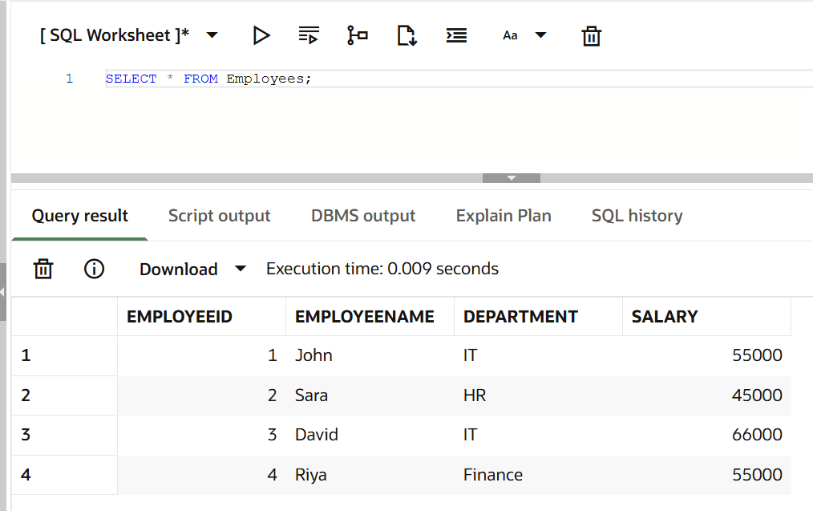

Scenario 3: Transfer Funds
Objective
Write a stored procedure TransferFunds that transfers a specified amount from one account to another after verifying that the source account has sufficient balance.
Step 1: Create the Stored Procedure
CREATE OR REPLACE PROCEDURE TransferFunds(
p_FromAccount IN NUMBER,
p_ToAccount IN NUMBER,
p_Amount IN NUMBER
)
IS
v_Balance NUMBER;
BEGIN
SELECT Balance
INTO v_Balance
FROM Accounts
WHERE AccountID = p_FromAccount;
IF v_Balance >= p_Amount THEN
UPDATE Accounts
SET Balance = Balance - p_Amount
WHERE AccountID = p_FromAccount;
UPDATE Accounts
SET Balance = Balance + p_Amount
WHERE AccountID = p_ToAccount;
COMMIT;
ELSE
DBMS_OUTPUT.PUT_LINE('Insufficient Balance');
END IF;
END;
/
Step 2: Execute the Procedure
BEGIN
TransferFunds(101, 102, 5000);
END;
/
Step 3: Verify the Result
SELECT * FROM Accounts;
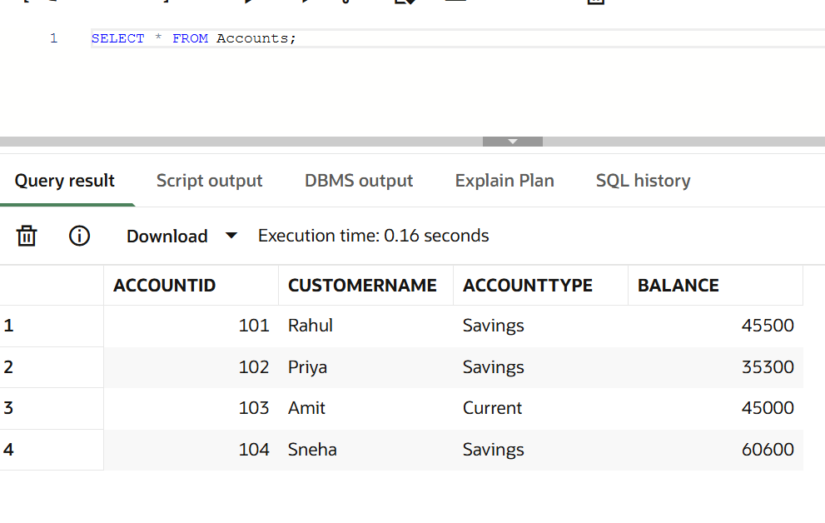
Conclusion:
The PL/SQL stored procedures were successfully implemented and executed.
- The ProcessMonthlyInterest procedure correctly applied a 1% interest rate to all savings accounts.
- The UpdateEmployeeBonus procedure successfully increased employee salaries based on the specified department and bonus percentage.
- The TransferFunds procedure successfully transferred funds between accounts after verifying sufficient balance, ensuring accurate and secure transaction processing.
Thus, the objectives of implementing and executing PL/SQL stored procedures for common banking operations were successfully achieved.

